Setting up your new Berkshire Health Systems patient portal

- You will receive an email from noreplyMeditechPatientPortal@BHS1.org in the email account you provided to registration staff

- At the bottom of the email you will see a link that says “Click here to sign in” Click on the link.
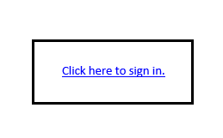
- You will then be asked to create a Logon ID, Password and a Security question
  - Your LogonID must contain:
    - At least 6 characters but less than 18
  - Your Password must contain:
    - At least 6 characters but less than 20
    - At least one number
    - At least one Uppercase letter

- You will be presented with the user agreement, to which you must accept to create your portal. To accept, scroll to the bottom of the screen and click on the blue “Accept” button.

- Your portal setup is now complete!

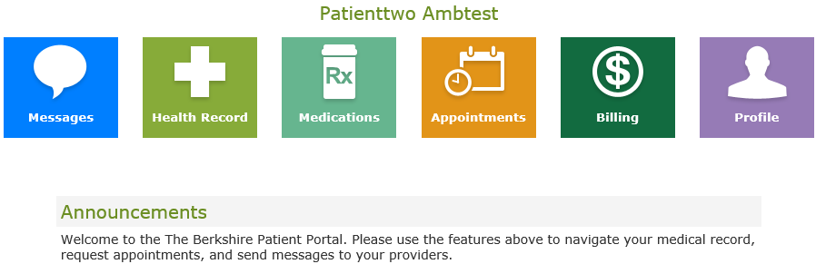

If you experience any issues please reach out to the Berkshire Patient Portal Liaisons via email at berkshireportal@bhs1.org. or phone 413-447-2505

